Welcome to the Brand Partner Portal pilot

Thank you for taking part in the Pilot to test out the Brand Partner Portal.
To get started on the BP Portal, please see Quick Start Guide 1 _ Getting Started Using The Portal App v1.4.
Once you have looked at that guide, that log into the Brand Partner Portal and take a look at the ‘Our Organisation Information’ section.
This is the area we want you to focus on until 4 September. We’ll send you instructions for the next phase of the pilot before 7 September.

Our Systems
This section asks you to indicate which system(s) you use for several key functions, namely (1) case, contact and rostering management, (2) HR, (3) Finance. As Partners may use several systems for each of these functions, there is room for up to three in each category. This section also asks you to indicate which systems or suppliers you use for payroll, retail, banking and direct debiting. A further question asks you to indicate whether you use Charitylog or not.
This information will support the further development of the Network Infrastructure Programme, enable clear understanding of the key systems and supplier in use across the network, and allow Age UK to link Partners to promote peer to peer support.
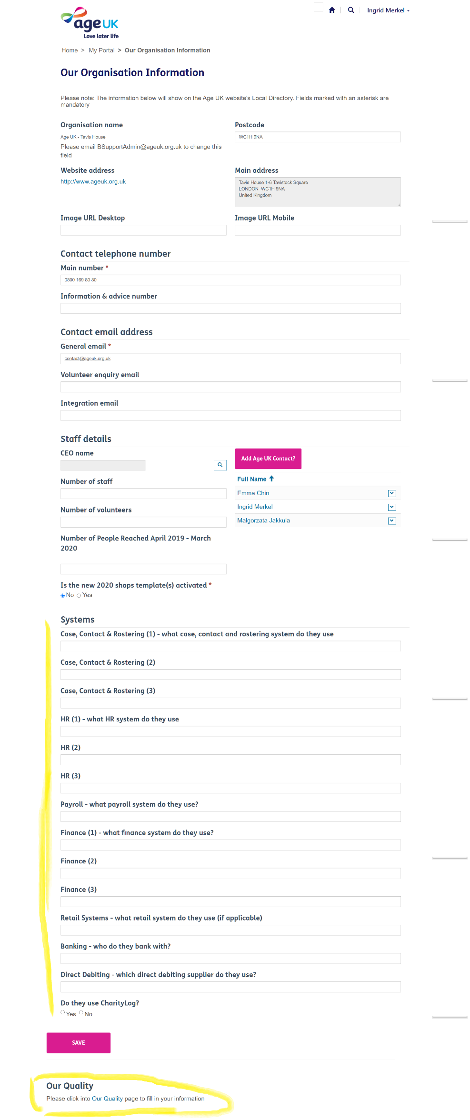

Our Quality

Serious incidents or critical issues
This section asks you to indicate whether any serious incidents or critical issues have occurred in your organisation within the last year and describes who you should inform at Age UK.

Your answers not only help us to follow up with your organisation and offer support but also help us monitor any patterns of incident type occurring in the network and explore where we may need to offer additional guidance and support to address these issues.

Please review this section with your board of trustees and submit your responses as part of your CQS Annual Return.

All serious incidents and / or critical issues should be reported immediately to Age UK, via the Partner helpdesk - partnership@ageuk.org.uk. Further guidance can be found in the ‘Managing and Reporting a Serious Incident’ document.

Completing this section:

In this section, we ask you to indicate if an incident or 'critical issue' has occurred in the last twelve months.

Most of these questions ask for a ‘yes’ or ‘no’ answer, but some also include an ‘N/A’ option (i.e. ‘not applicable’) to use if this situation didn’t occur or isn’t relevant.

